**First Steps for connecting to BeagleBone SensorGnome (only need to do once).**

1. **Install iTunes.** iTunes includes a service called Bonjour that facilitates communication between the computer and the SensorGnome

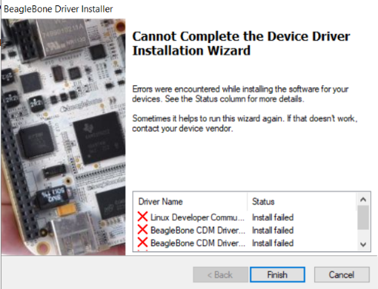

1. **Install BeagleBones drivers**. [Direct link to x64 Windows Driver here](https://beagleboard.org/static/Drivers/Windows/BONE_D64.exe). More information here and other versions here, about halfway down the page: <http://beagleboard.org/getting-started>

*Note: Sometimes Windows prevents these drivers from being installed since they are unsigned. There may not be any error message regarding the reason for the installation failure (see figure 1).*

*Instructions on how to temporarily disable these security checks so that the drivers can be installed* [*can be found here*](https://www.howtogeek.com/167723/how-to-disable-driver-signature-verification-on-64-bit-windows-8.1-so-that-you-can-install-unsigned-drivers/) *(option 2 is simplest). Restart your computer after you have successfully installed the drivers in order to reset the security bypass.*

1. **Install** [**FileZilla**](https://filezilla-project.org/) as an FTP client for transferring files between the computer and the SensorGnomes.
2. 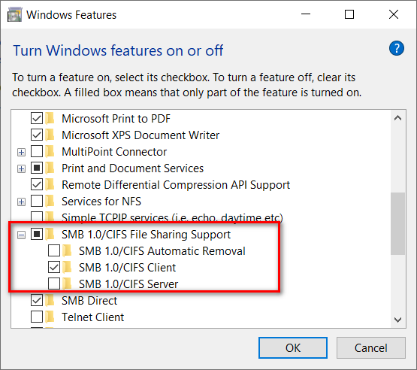**Allow SMBv1 connections on Windows.** Later versions of Windows block connections using this protocol since it's not as secure. This can be overridden by going to Control Panel > Programs > Turn Windows Features On or Off > Expand SMB 1.0/CIFS File Sharing Support. Toggle "SMB 1.0/CIFS Client" On (see Figure 2). More info here: <https://www.windowscentral.com/how-access-files-network-devices-using-smbv1-windows-10>.